Crescent

Decrescent

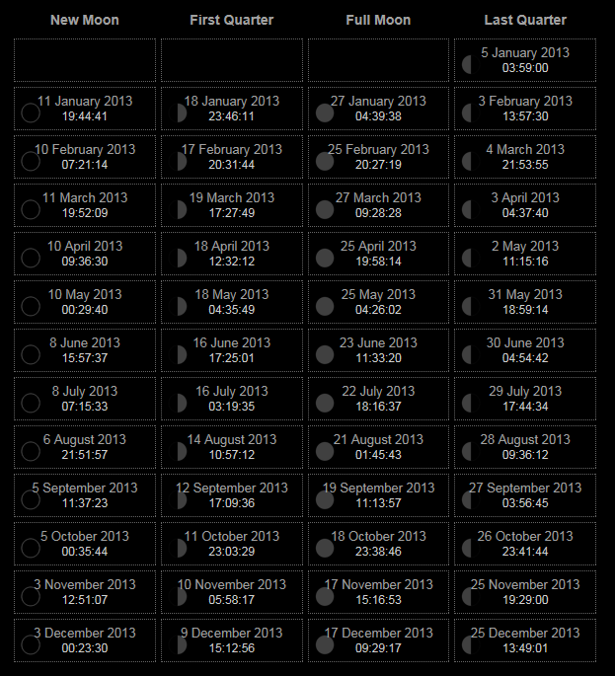

[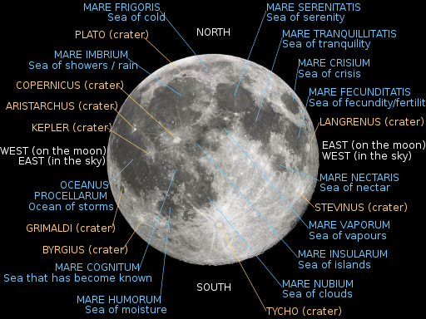](http://upload.wikimedia.org/wikipedia/commons/6/61/Moon_names.svg)

Risk Assessment: Avoid loss of dark adaptation by using red filter on torch, don’t get to cold.

Equipment Needed:

Weather Forecast:

Location:

Phases of the Moon:

Duration:

Start Time:

Date:

Project Title:

The **lunar maria** play[/](http://en.wikipedia.org/wiki/Wikipedia:IPA_for_English)[ˈmɑriə](http://en.wikipedia.org/wiki/Wikipedia:IPA_for_English#Key)[/](http://en.wikipedia.org/wiki/Wikipedia:IPA_for_English) (singular: **mare** [/](http://en.wikipedia.org/wiki/Wikipedia:IPA_for_English)[ˈmɑreɪ](http://en.wikipedia.org/wiki/Wikipedia:IPA_for_English#Key)[/](http://en.wikipedia.org/wiki/Wikipedia:IPA_for_English))[[1]](http://en.wikipedia.org/wiki/Lunar_mare#cite_note-0) are large, dark, [basaltic](http://en.wikipedia.org/wiki/Basalt) plains on [Earth](http://en.wikipedia.org/wiki/Earth)'s [Moon](http://en.wikipedia.org/wiki/Moon), formed by ancient [volcanic](http://en.wikipedia.org/wiki/Volcanic) eruptions. They were dubbed *maria*, [Latin](http://en.wikipedia.org/wiki/Latin) for "seas", by early astronomers who mistook them for actual [seas](http://en.wikipedia.org/wiki/Sea). They are less reflective than the "highlands" as a result of their iron-rich compositions, and hence appear dark to the naked eye. The maria cover about 16 percent of the lunar surface, mostly on the near-side visible from Earth. The few maria on the far-side are much smaller, residing mostly in very large craters. The traditional nomenclature for the Moon also includes one *oceanus* (ocean), as well as features with the names *lacus* (lake), *palus* (marsh) and *sinus* (bay). The latter three are smaller than maria, but have the same nature and characteristics.

Key Words:

Terminator

Cresent

Decresent

Mare